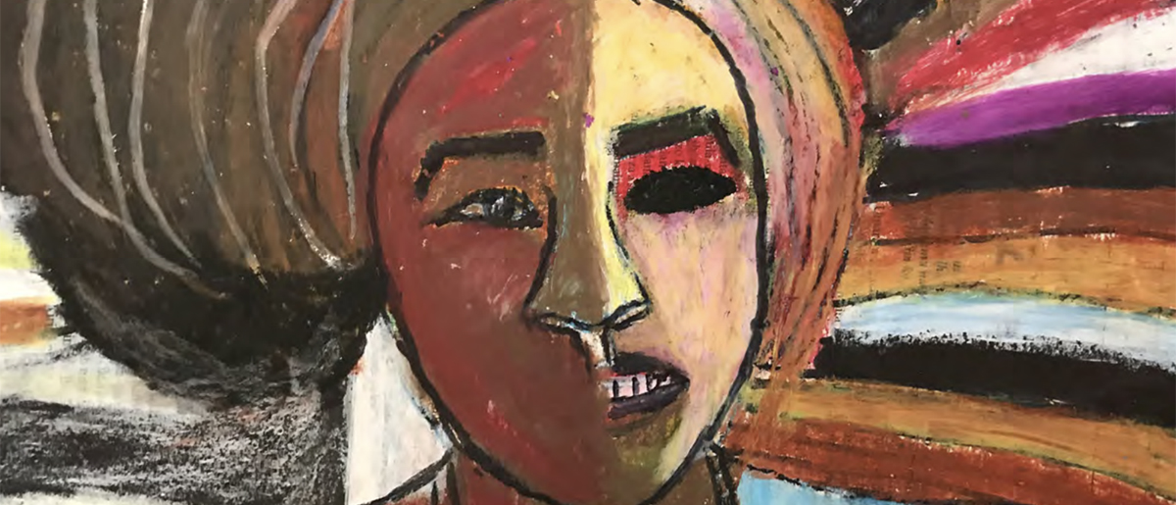iom manual on community-based mental health and psychosocial support in emergencies and displacement

FEEDBACK FORM

introduction:
Thank you in advance for your feedback. The purpose of collecting feedback on the manual is to:
- Gather tools, resources, best practices, and case studies that reviewers would like to be included in the manual
- Refine the content of the manual to represent the realities of designing, implementing and evaluating community-based MHPSS programs in emergencies and displacement
- Create a more effective, accurate and usable resource for MHPSS practitioners and scholars
The following are a series of survey scale and open-ended questions. Please feel free to answer some or all of the questions, and to provide feedback on the whole manual or on specific chapters.

personal information:
Please note that this section is optional. If you would like to be recognized for your contribution, please do provide your name and contact. We will contact you for your approval before publishing any proposed feedback.
Name:

Organization/institution and role:

Country of past and current work (as it relates to feedback provided):

Email:

Would you like to be listed as a contributor to the manual if your feedback is accepted? (Please note that we will contact you for further details before doing so).
- Yes
- No
- If there are specifications to your name or organization’s name being included, please check this box and describe below:

SECTION I: Overall evaluation of the manual
Did you find the manual useful?

Not at all useful | 1 | 2 | 3 | 4 | 5 | Extremely Useful

Please explain how you think it can be more useful:

Did you find the manual clear?

Not at all clear | 1 | 2 | 3 | 4 | 5 | Extremely clear

Please explain how you think it could be clearer:

Which chapters of the manual did you find to be the least clear? Please check all that apply.
- Introduction
- Chapter 1. Concepts and models of work
- Chapter 2. Engaging with communities
- Chapter 3. Assessment and mapping
- Chapter 4. Psychosocial mobile teams
- Chapter 5. Sociorelational and cultural activities
- Chapter 6. Creative and art-based activities
- Chapter 7. Rituals and celebrations
- Chapter 8. Sport and play
- Chapter 9. Non-formal education and informal learning
- Chapter 10. Integration of mental health and psychosocial support in conflict transformation and mediation
- Chapter 11. Integrated mental health and psychosocial support, and livelihood support
- Chapter 12. Strengthening mental health and psychosocial support in the framework of protection
- Chapter 13. Counselling
- Chapter 14. Community-based support for people with severe mental disorders
- Chapter 15. Technical supervision and training
- Chapter 16. Monitoring and evaluation
- Annex 1. Inter-agency coordination
- Annex 2. Ethical considerations
Please explain why:

Which chapters of the manual did you find to be the most clear? Please check all that apply.
- Introduction
- Chapter 1. Concepts and models of work
- Chapter 2. Engaging with communities
- Chapter 3. Assessment and mapping
- Chapter 4. Psychosocial mobile teams
- Chapter 5. Sociorelational and cultural activities
- Chapter 6. Creative and art-based activities
- Chapter 7. Rituals and celebrations
- Chapter 8. Sport and play
- Chapter 9. Non-formal education and informal learning
- Chapter 10. Integration of mental health and psychosocial support in conflict transformation and mediation
- Chapter 11. Integrated mental health and psychosocial support, and livelihood support
- Chapter 12. Strengthening mental health and psychosocial support in the framework of protection
- Chapter 13. Counselling
- Chapter 14. Community-based support for people with severe mental disorders
- Chapter 15. Technical supervision and training
- Chapter 16. Monitoring and evaluation
- Annex 1. Inter-agency coordination
- Annex 2. Ethical considerations
Please explain why:

Which chapters of the manual did you find least relevant to your work? Please check all that apply.
- Introduction
- Chapter 1. Concepts and models of work
- Chapter 2. Engaging with communities
- Chapter 3. Assessment and mapping
- Chapter 4. Psychosocial mobile teams
- Chapter 5. Sociorelational and cultural activities
- Chapter 6. Creative and art-based activities
- Chapter 7. Rituals and celebrations
- Chapter 8. Sport and play
- Chapter 9. Non-formal education and informal learning
- Chapter 10. Integration of mental health and psychosocial support in conflict transformation and mediation
- Chapter 11. Integrated mental health and psychosocial support, and livelihood support
- Chapter 12. Strengthening mental health and psychosocial support in the framework of protection
- Chapter 13. Counselling
- Chapter 14. Community-based support for people with severe mental disorders
- Chapter 15. Technical supervision and training
- Chapter 16. Monitoring and evaluation
- Annex 1. Inter-agency coordination
- Annex 2. Ethical considerations
Please explain why:

Which chapters of the manual did you find most relevant to your work? Please check all that apply.
- Introduction
- Chapter 1. Concepts and models of work
- Chapter 2. Engaging with communities
- Chapter 3. Assessment and mapping
- Chapter 4. Psychosocial mobile teams
- Chapter 5. Sociorelational and cultural activities
- Chapter 6. Creative and art-based activities
- Chapter 7. Rituals and celebrations
- Chapter 8. Sport and play
- Chapter 9. Non-formal education and informal learning
- Chapter 10. Integration of mental health and psychosocial support in conflict transformation and mediation
- Chapter 11. Integrated mental health and psychosocial support, and livelihood support
- Chapter 12. Strengthening mental health and psychosocial support in the framework of protection
- Chapter 13. Counselling
- Chapter 14. Community-based support for people with severe mental disorders
- Chapter 15. Technical supervision and training
- Chapter 16. Monitoring and evaluation
- Annex 1. Inter-agency coordination
- Annex 2. Ethical considerations
Please explain why:

Please check all chapters you request improvement on:
- Introduction
- Chapter 1. Concepts and models of work
- Chapter 2. Engaging with communities
- Chapter 3. Assessment and mapping
- Chapter 4. Psychosocial mobile teams
- Chapter 5. Sociorelational and cultural activities
- Chapter 6. Creative and art-based activities
- Chapter 7. Rituals and celebrations
- Chapter 8. Sport and play
- Chapter 9. Non-formal education and informal learning
- Chapter 10. Integration of mental health and psychosocial support in conflict transformation and mediation
- Chapter 11. Integrated mental health and psychosocial support, and livelihood support
- Chapter 12. Strengthening mental health and psychosocial support in the framework of protection
- Chapter 13. Counselling
- Chapter 14. Community-based support for people with severe mental disorders
- Chapter 15. Technical supervision and training
- Chapter 16. Monitoring and evaluation
- Annex 1. Inter-agency coordination
- Annex 2. Ethical considerations
The following sections will ask you to specify the types of improvements you seek to see in the manual.

SECTION II: revisions
This section provides a space for you to revise any passages in the manual you would like to see changed. Please feel free to revise sentences, paragraphs and whole passages.
When providing revisions, please provide the chapter, page, and line number as to where you think this revision should be included. When proposing a revision, please use this format:
Chapter: Page number: Line number(s):
The passage as it is in the manual:
Suggested alternative:

Example of revision:
Chapter: 1 Page: 25 Line numbers 8-9
Passage: Psychosocial workers may tend to generalize community characteristics to all assisted individuals and consider them immutable.
Suggested alternative: Psychosocial managers may tend to generalize community characteristics to all assisted individuals and consider them immutable.

SECTION III: Tools
This section provides a space for you to propose tools you wish to see added into the manual. Tools can be manuals, handbooks, booklets, training tools, assessment tools, research tools, videos, and articles.
When providing tools, please provide the chapter, page, and line number as to where you think this tool should be added. Please also provide the reference for any tools provided. Feel free to suggest as many tools as you would like.
When proposing a tool, please use this format:
Chapter: Page number: Line number(s):
Tool (written tool or link):
Why you think it is useful to add to the manual:
Example of tool suggestion:
Chapter: 3 Page: 41 Line numbers: Box 13, Line 4
Tool: IASC Reference Group Mental Health and Psychosocial Support Assessment Guide: https://interagencystandingcommittee.org/system/files/iasc_rg_mhpss_assessment_guide_.pdf
Why it is useful to be added in the manual: This is a tool for conducting MHPSS assessments that should be added to the list of guides for MHPSS assessments, because it is agreed upon by the IASC Reference Group on Mental Health and Psychosocial Support and therefore has numerous best practices identified.

SECTION IV: Case Studies
For this section, please provide any case studies that can serve as examples of the manual’s content. A case study should describe a specific example that illustrates a process, activity, event or outcome. Please feel free to include case studies in whichever formats you see fit (articles, videos, publications, project outcomes, informal reports, etc.).
When providing case studies, please provide the chapter, page, and line number as to where you think this case study should be added. Please also provide the reference for any case studies provided. Feel free to suggest as many case studies as you would like.
When proposing a case study, please use this format:
Chapter: Page number: Line number(s):
Case study (written case study or link):
Reference:
Why you think it is useful to add to the manual:

Example of case study suggestion:
Chapter: 7 Page: 90 Line numbers: 1
Case study: In 2015–2016, the Yazidi community in the northern part of Iraq welcomed back those Yazidi women who had been kidnapped into sexual slavery by ISIS, using traditional cleansing rituals, which allowed them to be fully reintegrated into their families, using a traditional form. This is an example of a collective ritual of transition used to respond to war-related adversity.
Reference:https://www.pri.org/stories/2017-09-12/photos-yazidi-women-undergo-rebirth-ceremony-after-isis-enslavement
Why you think it is useful to add to the manual: This is a direct example of a ritual that took place and which relates to the psychosocial wellbeing of the Yazidi community, and it shows how rituals could potentially be supported by a CB MHPSS program in the context of northern Iraq.

SECTION V: other
Please provide any other feedback in this section:

